B | I | N | G | O
Visited Virtual Booth | Learned about a Sponsors New product or Service | Made homemade bread | Met with a Sponsor face-to-face (via Zoom) | Visited Virtual Booth
Attended a Virtual Happy Hour | Visited Website  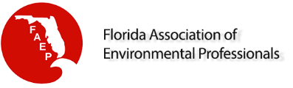 | Requested additional information from a Sponsor | Went on a hike | Provided Sponsor with your contact information
Picked up a to-go cocktail | Connected with Sponsor on Instagram | FREE SPACE  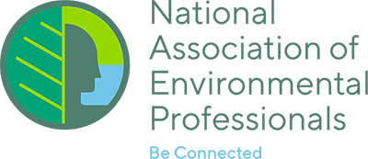 | Requested a quote for services from a Sponsor | Visited Virtual Booth
Visited Sponsor’s website for additional information | Visited Website  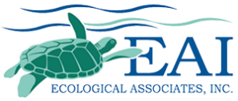 | Started a new DIY project | Visited Website | Followed and “Liked” Sponsor on Facebook
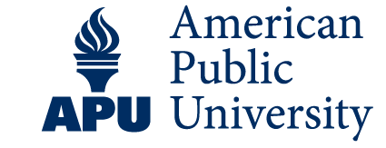  Visited Virtual Booth | Wore pajama bottoms to a professional Zoom meeting | Visited Virtual Booth | Attended an NAEP Daily Networking Session | Collected contact information from Sponsor Representative

INSTRUCTIONS:

- Drag and drop the circles over the bingo boxes that apply to you
- Fill out your contact information and email back your completed board to the NAEP Conference Committee for a chance to win a $100 gift card.
- Bingo cards should be submitted to Ryan Goldman at rgoldman@broward.org

NAME:

COMPANY:

EMAIL:

PHONE:

